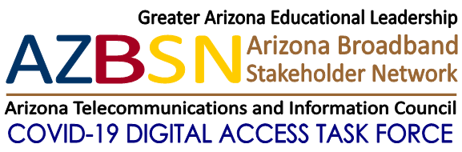

Federal Communications Commission
Emergency Broadband Benefit Program
Help Get Arizona Households Connected!
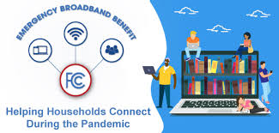

TO: Arizona government, education business and nonprofit organizations
FROM: Steve Peters, Coordinator, COVID-19 Digital Access Task Force
520-321-1309, email
Note: We are asking you to help get the word out to your contacts and networks. Feel free to forward this email as is, or modify it for your needs. You can remove our logo and add yours, and change it any way that will be most useful for you. We know people will be more responsive receiving communication from people and organizations they know and trust.

FCC Emergency Broadband Benefit Program – How You Can Help!
On May 12 the FCC will launch the new Emergency Broadband Benefit Program (EBB). The EBB addresses the unprecedented need by low-income households for affordable digital access resources including Internet and devices such as computers and cell phones. The EBB provides eligible households a subsidy of up to $50 per month on Internet service, or $75 per month for those living on Tribal lands. The EBB may also provide eligible households a one-time discount of up to $100 to purchase a laptop, desktop or tablet computer. It is urgent that we get the word out and help eligible low-income households register for this program ASAP. Today many Arizona citizens, including students, parents, teachers, seniors, businesses and employees, and library patrons still do not have access to affordable devices or the Internet. EBB is a limited funding and limited duration benefit program so we need to act now to help Arizona low-income consumers get signed up before time and money run out.
A statewide Arizona coalition of government, education and nonprofit organizations is asking for your participation in a statewide campaign to get eligible households signed-up ASAP. We know that for many people signing up for government programs can be scary and complicated so we are asking schools, libraries, non-profit and faith-based organizations, social service and health care agencies, and local and state governments to help get the word out to your constituencies about the EBB program, and to help them register for these benefits. The Coalition is collaborating on a promotion campaign, and EBB Toolkit to make it easier for your organization to access the information you may need. The toolkit was developed to share with your networks, school districts, education leaders, nonprofits, community organizations and others. ​The toolkit is housed on the Connect Arizona website, which also provides resources and guidance for individuals needing virtual learning opportunities for students, access to free WIFI hotspots and digital tech support.
The toolkit includes:
- A PDF showing step-by-step instructions on how individuals can ​apply for EBB discounts
- An Emergency Broadband Benefit FAQ sheet
- The FCC Emergency Broadband Benefit program guide
- A Flyer in English outlining the program and eligibility requirements
- A Flyer in Spanish outlining the program and eligibility requirements
- A Half-page flyer in English that can be printed and distributed locally
- A Half-page flyer in Spanish that can be printed and distributed to locally
- A sample email to use as a template to share out to your networks​
​Access the Toolkit Here

Here Is How You Can Help
- ​Become an Outreach Partner. Get your organization involved to help get the word out to your constituencies about the EBB program, and to help them register for these benefits.
- Identify a Point of Contact within your organization to learn about the EBB, and the processes to help eligible consumers sign-up and take advantage of these programs
- Print and distribute EBB flyers to your constituents
- Provide funding to pay for flyers

Want to help? Contact:
- Tracey Beal tracey@schoolconnectaz.org
- Ilana Lowery at ilowery@commonsense.org
- Nicole Umayam numayam@azlibrary.gov
- Cindy Hogan chogan@unitedwaytucson.org

